Slow phantom (with glycerol, top layer)

50-50 glycerol

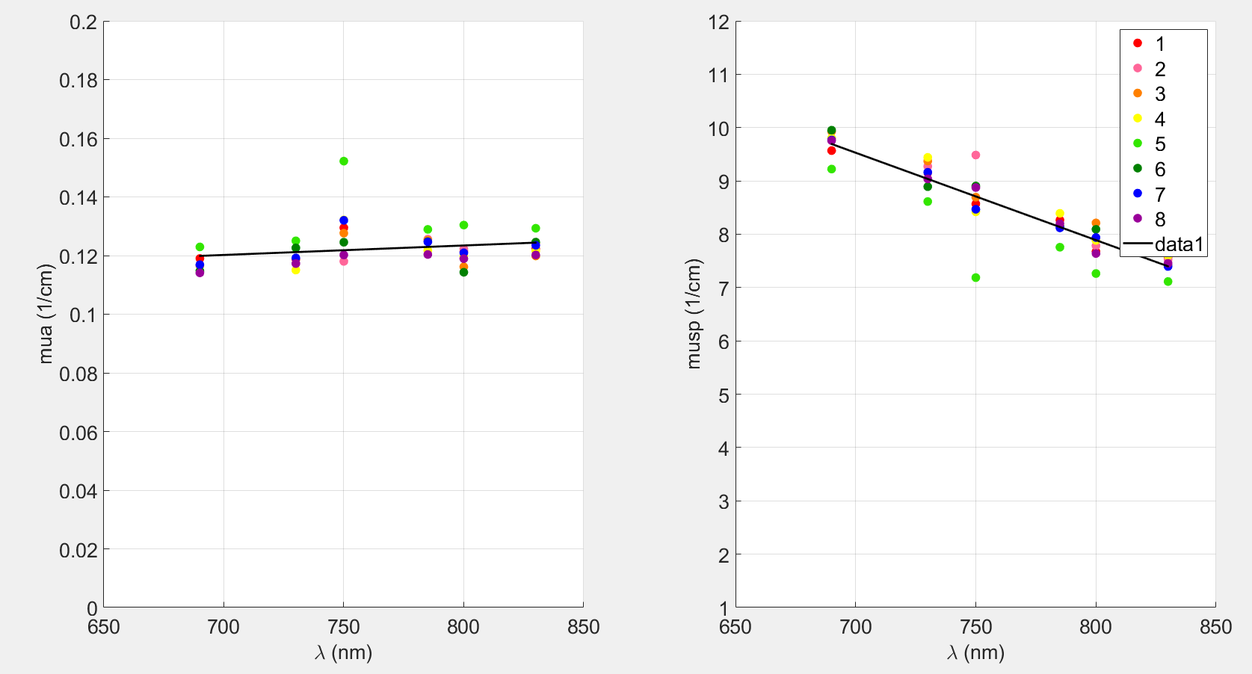

Assuming n=1.33 (I think this is what Erin wanted to use but I’m not sure if It’s good idea)

mua_850nm =

0.1251

musp_850nm =

7.0701

DB:

15mm: 0.1817

20mm: 0.1830

Fast phantom (no glycerol, bottom layer)

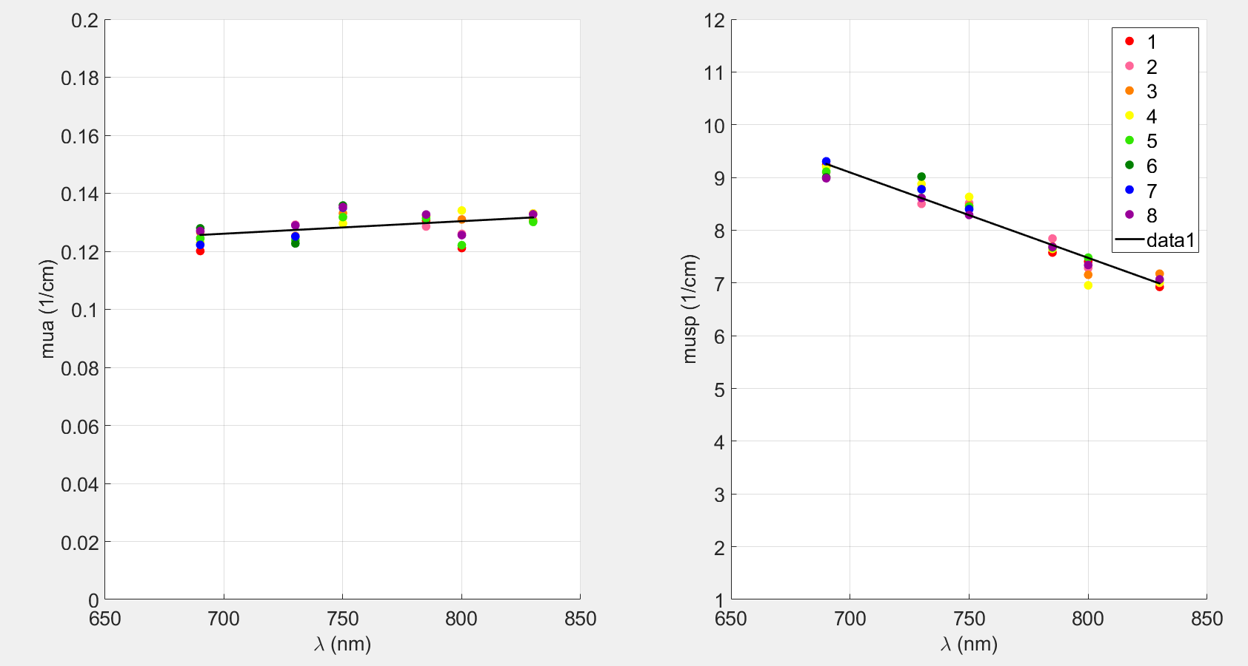

mua_850nm =

0.1325

musp_850nm =

6.6660

DB:

15mm: 0.6761

20mm: 0.6718

Slow phantom (with glycerol, top layer)(while changing n = 1.39 50-50 glycerol)



Assuming n=1.39 (50-50 glycerol)

mua_850nm =

0.1302

musp_850nm =

6.7607

DB:

15mm: 0.1784

20mm: 0.1810